

`

TOM Integration
Interface Specification
On
Base Product (approved)
From IDS to CRDB

[S009]

Project BEN Code: | W60416
Author: | Debasis Pattanaik
Date: | 19/04/2007
Version: | 0.1D
Status: | Draft
Modified By:
Reviewed By: | Andrew Barker

Change Record

Author | Date | Version | Change Reference, description
Debasis Pattanaik | 19-04-2007 | 0.1D | Draft

Reviewers

Name | Date | Version | Position
Andrew Barker |  | 0.1D | Engagement Architect

At least one reviewer is required.

Sign-Off

By signing this form, I understand and agree with the contents of this document.

Business Owner/Customer | Andrew Barker
Position | Engagement Architect
Signature | <Physical signature or via email approval>
Date | dd/mm/yyyy (<version signed off>)

Distribution List

Name | Date of Issue | Version
Andrew Barker
John Cowper
Jon Braggs
David Onyett
Venkateswara Rao

Document Source
DocShare: UK IT/TOM Integration/Shared Documents

Related Documents

A complete interface specification requires three documents- an Interface Specification, an Information Architecture Context diagram, and a Mapping spreadsheet. This section identifies these documents plus other documents as appropriate.

Information Architecture Context diagram
S009 Information Context Diagram - Base Product(approved) Information.vsd

Mapping spreadsheet
S009- Base Products(approved) - IDS to CRDB Mappings.xls

Other Reference Documents
Interface 080 Product Description v3.1.doc
Table of Contents
1 Introduction 6
1.1 Purpose of Document 6
1.2 Background 6
1.3 Scope 6
2 Description and Requirements for the End-to-End Interface 7
2.1 Description of the End-to-End Interface 7
2.2 Architecture 7
2.3 Requirements of the End-to-End Interface 7
2.4 Non-Functional Requirements of the End-to-End Interface 8
3 Processing Required in the Extract Stage of the Interface 9
3.1 Scope 9
3.2 Source Message Schema 9
3.3 Message Transport Details 9
4 Processing Required in the SSIS Stage of the Interface 10
4.1 Scope 10
4.2 Package Overview 10
4.3 Data Validation 10
4.4 Filtering 10
4.5 Mapping 10
4.6 Target Message Schema 10
4.7 Message Transport Details 11
4.8 Naming and Configuration 11
4.9 Environment and Security Context 12
4.10 Non-Functional Requirements 12
5 Processing required in the <third stage of the interface> 13
5.1 Scope 13
5.2 Data Validation 13
5.3 Filtering 13
5.4 Mapping 13
5.5 Target Message Schema 13
5.6 Message Transport Details 13
5.7 Naming and Configuration 13
5.8 Environment and Security Context 13
5.9 Non-Functional Requirements 13
6 Testing Deliverables 14
7 Deployment 15
8 Assumptions and Outstanding Issues 16
8.1 Assumptions 16
8.2 Outstanding Issues 16
Appendix A Volumes 17
Appendix B Glossary 18
Appendix C Document Control 19

Introduction

Purpose of Document
The purpose of this document is to describe the interfacing requirements w.r.t Base Products (approved) data between the IDS to CRDB. The document is of a sufficiently technical nature to allow a developer to build an actual interface. Additionally the document contains detail that might sit logically within a Technical System Design (TSD) document, but is contained here for expediency. There is therefore no associated TSD for this interface.

This interface is for both US and Turkey implementations.

Background
As part of Tesco Operating Model program, there is requirement to bridge the functionalities of enterprise applications including IDS and CRDB. To achieve this functionality, high level process flow architecture has been designed and approved by Tesco’s Enterprise Architecture team. As part of this process flow architecture there is a set of interfaces that has been identified to be developed to transfer Base Products (approved) data from IDS into CRDB.

Scope
The Interface Specification covers:

- audit requirements across the interface
- security requirements across the interface
- timing/frequency requirements or constraints
- support requirements
- archiving
- the data format to be used for the interface at each stage (e.g. xml messages)
- the normal processing required at each stage
- recovery from failure required at each stage
- volumes.

Note that it is Tesco strategy to avoid placing any business logic in integration layer processing.

Description and Requirements for the End-to-End Interface

Description of the End-to-End Interface
The interface is an extract of Base Products (approved) Data from IDS using Common Forms and uploads into the CRDB as positional Flat file. This interface will be delta upload in nature.

The interface is dealing with transfer of Base Products (approved) Data from IDS to CRDB. The resulting format is a positional flat file. The format of this file will be as defined by the existing UK SRM Interface specification number 080.

The target shared locations will be put in a configuration state so that while in implementation this can be changed as per the requirement.

Architecture
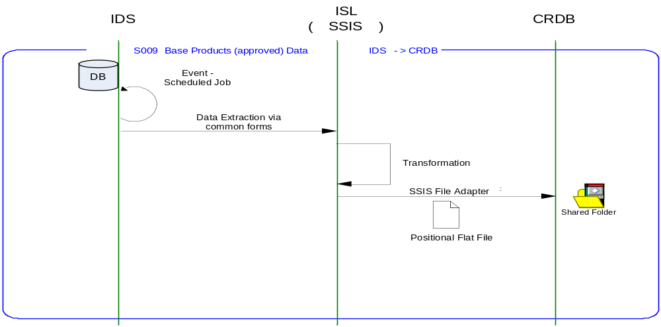

Requirements of the End-to-End Interface
The interface will run once a day, on scheduled basis, and consists of a SQL Server Integration Services package that extracts data from the IDS, and formats it into the target file format.

The interface is meant to run nightly at a pre-configured time which on completion is expected to upload the Base Products (approved) Data in a Flat file into CRDB shared directory.

The interface will make use of the audit and traceability components that are being developed as part of the Operational Framework stream. These components will be pluggable, and will be useable from BizTalk, RTI, and SSIS. At the time of writing (2007-01-18) the components are in design. Although not ready for use, they are included on the Information Architecture Context diagram where their functionality is required. Developers should put a ‘placeholder’ in their code / configurations as appropriate.

Non-Functional Requirements of the End-to-End Interface

Audit Requirements | The interface will use the components provided by the Operational Framework to satisfy audit requirements.
Security Requirements | The interface executes within a secure private domain. There are no additional security considerations required.
Timing/Cut-off Constraints | To be finalised.
Performance Requirements | The interface should be capable of extracting data from IDS using Common Forms, delivering the resulting data to CRDB in form of Flat file before the identified cut-off time. The interface should run on scheduled batch basis.
Reliability and Availability Requirements | The interface-run should be non atomic in nature. Appropriate mechanisms should be in place to raise/alert appropriate parties.
Scalability Requirements | No Scalability requirement. The requirement is to deliver a single extract. It is anticipated that the volume of data transferred will continue to remain within the capability provided by this implementation.
Operational Support Requirements | The scheduled start of the extract job and/or the completion of the target table update should be defined as IMOF events.
Likelihood of Change Requirements | There is no such requirement
Cultural/Global Consideration Requirements | Although multi-byte character set support is not required for US or Turkey, the interface will support multi-byte character sets through integration.
Legal Requirements | N/A
Compliance To Standards Requirements | No compliance exceptions.

Processing Required in the Extract Stage of the Interface

Scope
This section describes the data sources required by this interface and the services used to access the data.

Source Message Schema
The data for this interface resides in the IDS. Common Form Service TOM.Common.Schema.Item is called by the SSI package to extract the Base Product (approved) data. The services are exposed as stored procedures and return row sets representing Base Product in the Item Common Form.

Message Transport Details

Feature | Specification | Additional Information
Source System Name | IDS
Source Platform / OS | Windows 2003 Server
Source Physical Location | SQL SERVER 2005
Source Underlying Data Storage Technology | RDBMS
Target System Name | SSIS
Target Platform / OS | Windows 2003 Server
Target Physical Location | SQL SERVER 2005
Target Underlying Data Storage Technology | RDBMS
Transfer Function | HTTP (Put/Post) □  HTTPS (Put/Post) □  Message Queue □  FTP □  File Drop(Windows) □  (XCOM) □  Common Forms ☑
Data Format. | XML □  Delimited □  Positional □  RDBMS ☑
Decryption/Encryption | No
Decompression/Compression | No
Transmission Mode | Synchronous □  Asynchronous ☑  Bulk Data □
Real-time/Scheduled Batch | Not yet decided
Archiving | There is no requirement to archive the messages.
Logging | Log via the Operational Framework.
Error Handling | Not yet decided  Processing should prevent sending of duplicate messages, unless this occurs during recovery from failure.

Processing Required in the SSIS Stage of the Interface

Scope
This section describes the discreet steps within the SSIS package to extract and format data. The target file format is included in this section.

Package Overview
SSIS extracts the Base Product (approved) data from IDS using Common Forms, nightly at predefined time. In turn, the data is formatted as per the below layouts file structure and uploaded same into the CRDB allocated inbox shared directory.

Data Validation
N/A

Filtering
There is no filtering requirement.

Mapping
Mapping document will be provided subsequently.

Target Message Schema
Flat File Field Name | Type | Length | Description
Record Type | Alphanumeric | 2 | Set to '00' for the header record.
Date/Time File Created | Alphanumeric | 14 | File Creation Date
Sequence number | Alphanumeric | 6 | Set to '000000'
Date | Alphanumeric | 8 | System date
File Id | Alphanumeric | 3 | Set to '000'
Begin Group
Record Type | Alphanumeric | 2 | Set to '01' for the detail record.
TPNB | Numeric | 9 | SKU Item ID
TPNB Desc | Alphanumeric | 48 | SKU Item description
Launch Date | Numeric | 8 | SKU item launch date.
Authorisation Status | Text | 1 | SKU item status
End Group
Record Type | Alphanumeric | 2 | Set to '99' for the footer records
Record count | Alphanumeric | 10 | this will count data records only. The number will contain leading zeros.

Message Transport Details
For messages destined for CRDB system, the following applies.

Feature | Specification | Additional Information
Source System Name | SSIS
Source Platform / OS | SQL Server 2005
Source Physical Location | IDS
Source Underlying Data Storage Technology | RDBMS
Target System Name | CRDB
Target Platform / OS | Windows
Target Physical Location | Configurable
Target Underlying Data Storage Technology | File-Based
Transfer Function | HTTP (Put/Post □  HTTPS (Put/Post) □  Message Queue □  FTP □  File Drop (Windows) □  (XCOM) □  RTI File Adapter □  SSIS File Adopter ☑
Data Format | XML □  Delimited □  Positional ☑  RDBMS □
Decryption/Encryption | No
Decompression/Compression | No
Transmission Mode | Synchronous □  Asynchronous ☑  Bulk Data □
Real-time/Scheduled Batch | RDBMS extract
Archiving | There is no archiving requirement
Logging  Should logs be kept of all actions? For how long should these be stored? | Logging should occur, such that the message can be recreated if necessary.
Error Handling | On fail move the file to the failed transmissions location. The file drop failure will be tracked through IMOF functionality and will be done through a change request.

Naming and Configuration

SSIS
Package Name: TOM_IDSCRDB_BaseProduct_approved_pkg
Name | IDSCRDBBaseProductApproved
<Placeholder for other package components/steps>
<Placeholder for other package components/steps>

Environment and Security Context
Account details will be included here once we have visibility of the environments.

Non-Functional Requirements
On successful delivery of the data to the target system, the audit log should be updated via the Operational Framework pipeline component or adapter (to be determined).

In the event of a failure of transformation of data should be written to the failed log database, and an alert should be raised.

Processing required in the <third stage of the interface>

Scope
There is no intermediate staging is required for this interface. So this section is not applicable.

Data Validation
Not Required

Filtering
Not Required

Mapping
Not Required

Target Message Schema
Not Required

Message Transport Details
Not Required

Naming and Configuration
Not Required

Environment and Security Context
Not Required

Non-Functional Requirements

Not Required

Testing Deliverables
This section should contain a list of discrete deliverables. The following table is an illustrative template only. The exact deliverables will depend on the technologies employed in the interface.

Deliverable | Description
TBD <stored proc name> | Common Form Stored Procedure
TBD <stored proc name> | Common Form Stored Procedure
TBD <service name> | Common Form Web Service
TBD <SSIS package name> | Package
TBD <RTI configuration file> | Xml configuration file exported from RTI. For testing, this should contain the configuration required to support this interface only.  For production, configuration should be documented under section 7 Deployment.
TBD <script name> | Unit Test Scripts. Scripts should be provided to:  - create databases (including stored procedures).  - populate with the minimum set of test data to satisfy functional requirements  - notes showing how to use scripts and describing the functions tested.
<installer> | Installers as appropriate to the technology being used.

Deployment

Assumptions and Outstanding Issues

Assumptions
ID | Assumption

Outstanding Issues
ID | Issue | To be addressed by
1 | Timings and cut-off constraints need to be defined. Require input from SRD. | Andrew Barker
2 | Deployment not yet considered | Andrew Barker
3 | Destination Shared location to be confirmed | Andrew Barker
4 | Error handling to be confirmed with respect to archiving process | Andrew Barker
5 | IMOF implementation need to be confirmed | Andrew Barker

- Volumes
- Glossary

Acronym | Term | Description
EAI | Enterprise Application Integration | The process of meeting the data requirements of applications by providing a message based transport from disparate data sources across all forms of enterprise technology.
EAI Layer | Enterprise Application Integration Layer | Refers to the integration services provided to implement EAI. In contrast to the EIA Layer for data services. See below.
EIA | Enterprise Information Architecture | Creation of a strategic single view of data across the enterprise.
Interface | Interface | Many definitions exist for 'interface'. In general, 'interface' refers to the link between a data source and a data target. And there are properties of the interface in this context. However more specifically 'interface' refers to one end of a data link, hence the terms source interface and target interface, and both the source interface and the target interface will have specific properties of their own.
RMS | Retek Merchandising System | Retek Merchandising System is getting installed for TESCO Merchandising operations in US. This system will governs the Merchandising operations; Receive base Master & Transaction data and from other systems and Provide data to next level of operation system as part of Retail systems chain.
IDS | Information Data Store | A store of data, logically residing in the EIA layer, that provides an authoritative single view of a discrete data component specific to the enterprise. Eg: Product, Store, etc. IDS's reside in the EIA Layer, and are accessed through the EAI Layer.
IMOF | Integration Management Operational Framework | IMOF is a framework which is pluggable to any Biztalk, RTI and SSIS for alerting, exception handling, defining rules, scheduling etc

- Document Control
Change Record

Author | Date | Version | Change Reference, description
Debasis Pattanaik | 19-April-2007 | 0.1D | Draft

Related Documents

Author | Date | Version | Title
Andy J Smith | 08/09/2006 | v3.1 | Interface 080 Product Description

Distribution

Name | Position | Approver/Contributor/Other
Andrew Barker | Engagement Architect
John Cowper | Solution Architect
Jon Braggs | Enterprise Architect
David Onyett | Project Lead
Venkateswara Rao | Delivery Manager

